NORWEGIAN PACIFIC MARITIME INC.

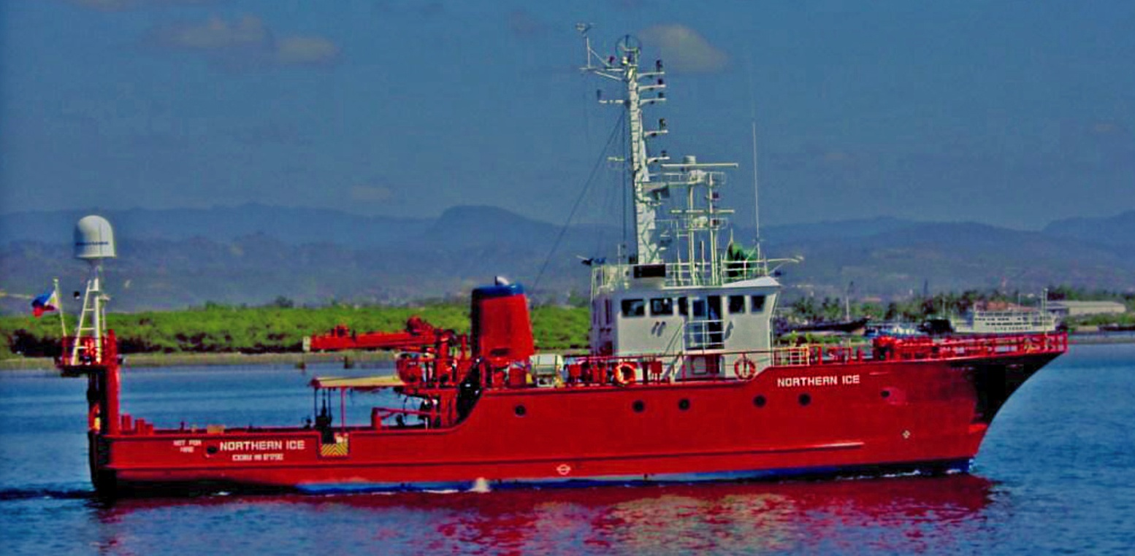
MV NORTHERN ICE

GENERAL INFORMATION |  |  | WHEELHOUSE
CLASS TYPE | SPECIAL PURPOSE VESSEL |  | RADAR | 2 PCS. ARPA Radar FURUNO FAR -2825/  FR-2020- 4A
IMO NUMBER | 8717582
OFFICIAL NUMBER | 21378809 |  | GPS | FURUNO GP80/GP 300 SC-50 SIMRAD
FLAG/COUNTRY | PHILIPPINE FLAG |  | RADIO
HULL MATERIAL | STEEL |  | EPIRB | GME MT401
BUILDER | KANAGAWA ZOSEN- KOB ,JAPAN |  | SART | SIMRAD SA50
YEAR BUILD | 1988 |  | VHF RADIO | FM-7500 FURUNO
MAIN ENGINE | DAIHATSU GDLM-22s ,900r.p.m. 1200 HP, I SET ME  driven Shaft Gen., 1 X 250 KVA |  | VHF PORTABLE (2 PCS.) | ICOM 45 AND 35
 |  |  | GMDSS EQUIPMENT | JSS-296 WITH DCS & NBDP A3 (JRC)
 |  |  |  | JUE-85 INMARSAT (JRC)
AUX ENGINE | YANMAR; 2 X 125 KVA |  |  | NCR-333A NAVTEX RECEIVER (JRC)
BOW THRUSTER | YES,1.5 TONS |  |  | RD-68 VHF (SIMRAD)
PROPELLER | KAMOME CPP 4- BLADES |  | DEPTH /FISH FINDER | FURUNO FCV-30 ; FCV-1500m/HS-111  -/S SONAR
SPEED | 9 KNOTS ,SERVICE ;
LENGTH (OVER ALL) | 32.78 M |  | AUTO PILOT | TOKYO KEIKI PR-2000
LENGTH (BET PP) | 27.85 M |  | SEARCH LIGHTS | 1
BEAM | 7.40 M |  | FACILITIES ON BOARD
DRAFT MAX | 3.49 M |  | COMPLEMENT | 17 PERSON
GROSS TONNAGE | 140 TONS |  | CABINS | 3 SINGLE CABIN; 7 DOUBLE CABIN
NET TONNAGE | 98 TONS |  | MESS HALL | 1
SAFETY EQUIPMENT | CLASS AND STATUTORY CERTIFICATES |  | DECK EQUIPMENTS
CLASS | (IRS) INTERNATIONAL REGISTER OF SHIPPING |  | DECK AREA | AFT 60 M²
 |  |  | CAPSTAN | 1 AFT DECK
CONDITION | FULLY OPERATIONAL IN CLASS |  | GROUND TACKLE | 2 ANCHORS
*VESSEL IS FULLY INSURED WITH P&I AND HULL &  MACHINERY INSURANCE* |  |  | DECK CRANE | 1-5 TONS
FUEL CONSUMPTION
MAIN ENGINE | 3,000 LITERS/DAY WITH SHAFT GEN.
GENERATOR SET | 450 LITERS/DAY
ENDURANCE | 5000 nm.
FUEL TANKS | 70 M³
WATER TANKS | 28 M³
WATER MAKER | 6, 000 LITERS/DAY

Bldg 1 Cebu Yacht Club, Pusok Lapu-Lapu City 6015; Tel No: (032) 3413853; Mobile 0917-3200016; email:subsee@mozcom.com; website: www.subsee-philippines.com

